**Name:**

**Roll no :**

**Group A Lab Assignment:** 3

**Subject:** PSDL

**Title:** Internal to internal memory transfer

**Assignment No: 3**

**Title :** Embedded C program to transfer element from 1 location to another

**Aim :** Write an Embedded C program to transfer element from 1 location to another

**Objective:** To develop and execute embedded C program to transfer element from 1 internal memory location to another internal memory location for PIC18FXXX microcontrollers**.**

**Theory:**

**1). Arrays in Embedded C programming of PIC microcontroller**

Array is defined as the collection of similar type of data items stored at contiguous memory locations. Arrays are the derived data type in C programming language which can store the primitive type of data such as int, char, double, float, etc. It also has the capability to store the collection of derived data types, such as pointers, structure, etc. The array is the simplest data structure where each data element can be randomly accessed by using its index number. Arrays are used for storing element, letters or message.

Embedded C arrays are declared in the following form  
type name [number of elements];  
For example, if we want an array of five integers , we write in C:  
int numbers[5];  
For a five character array  
char letters[5];  
type name [number of elements]={comma-separated values}  
For example, if we want to initialize an array with five integers, with 1, 3, 5, 0, 9, as the initial values: int number[5]={1,3,5,0,9};  
Example of array  
int Array[5] = {1,2,3,4,5};

**Procedure:**

**Step 1:** Open MPLABX IDE on the PC for program development and create a new project and save it in a new folder.

**Step 2:** Write the program in C language to transfer element from 1 internal memory location to another internal memory location.

**Step 3:** Build the program and create hex file. In case of errors correct program and rebuild to create hex file.

**Step 4:** Select Window->Target memory views->**Configuration bits** from tool bar. Select appropriate settings, generate source code and paste the configurations in the main program.

**Step 5:** Select debug project and then Finish debugger session from the tool bar.

**Step 6:** Select Window->Target memory views->**File Registers to view the output.**

**Source code :**

#include<stdio.h>

#include<stdlib.h>

#include<pic18f4550.h>

void main(void)

{

int temp,i;

int source1[]={0x21,0x22,0x23,0x24,0x25};

int dest[]={0x99,0x99,0x99,0x99,0x99};

for(i=0;i<=4;i++)

{

temp=source1[i];

source1[i]=dest[i];

dest[i]=temp;

}

}

**OUTPUT:**

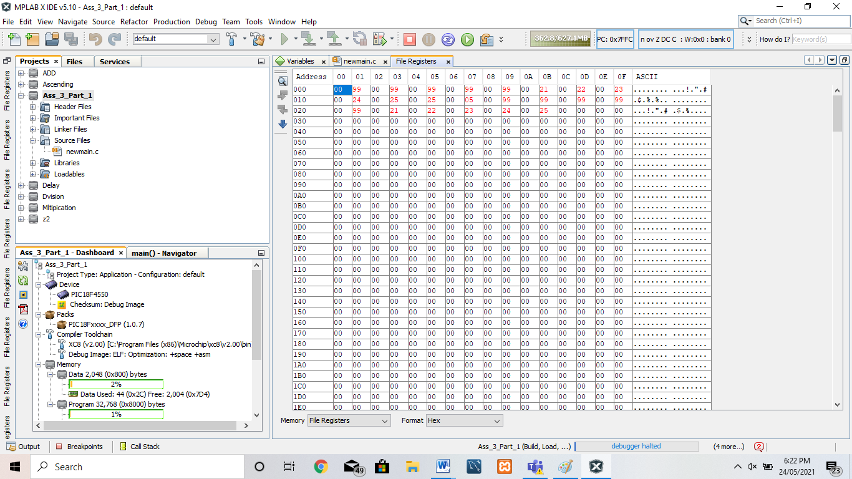

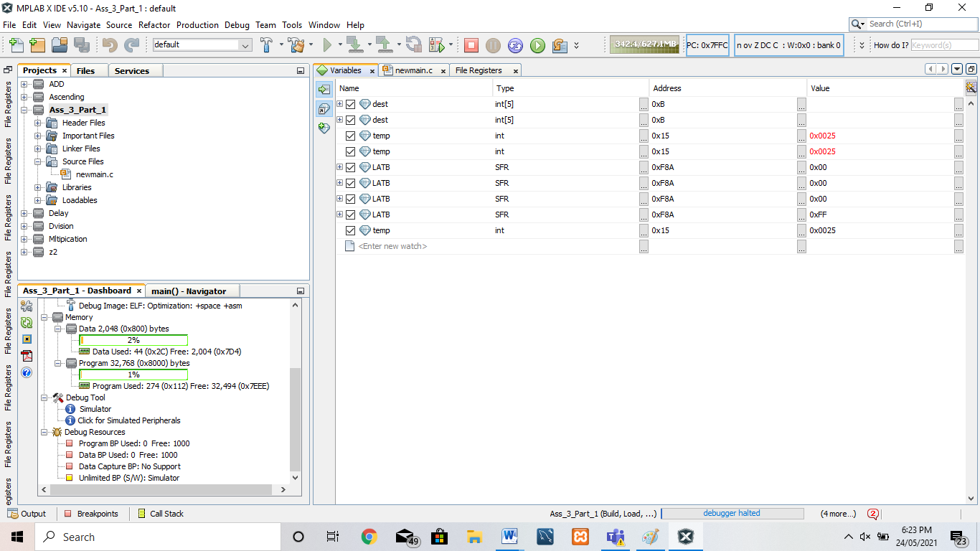

**Internal to External memory transfer is not possible**

**Conclusion:** Thus, we have studied embedded C program to transfer element from 1 location to another.